Railway TRANSCAER® - Pickering, Ontario

When: April 4-6 (0730- 1200hrs and 1300- 1700hrs approx..)

Where: Pickering Fire Department, 1616 Bayly Street, Pickering, ON.

PPE: For outside activities - reflective clothing, hard hats, safety glasses,
safety boots, gloves, rain gear if needed

Outside Events:
- CN Valve Trailer
- CP Foam Trailer
- ER Contractor

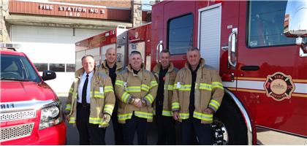

0730 - 0800  Times are approximate | Registration, coffee, snacks | ALL
0800 - 0815 | TRANSCAER Welcome/ Agenda/ Introductions/Safety Briefing | ALL
0815 - 0900 | CN Overview and Train Journal/Consist | CN – Dave Slauson
0900 - 0930 | Responder Safety | RAC Dangerous Goods – Andy Ash, with intro from DrainAll
0930-0940 | BREAK
0945 -1200 | Outside Displays (CN, CP and RAC) | ALL
1300-1315 | Registration, coffee, TRANSCAER Welcome/ Agenda/ Introductions/Safety Briefing | ALL
1315 - 1400 | CN Overview and Train Journal/Consist | CN – Dave Slauson
1400 - 1430 | Responder Safety | RAC Dangerous Goods – Andy Ash with intro from DrainAll
1430 -1445 | BREAK
1445-1700 | Outside Displays (CN, CP and RAC) | ALL
Questions?  Contact: | Andy Ash,647 206 2896, aash@railcan.ca





